On-Page SEO Introduction :

Task 1: Optimized HTML <title> Tag
Selected App: Zomato
Main Keyword: Food Delivery
HTML Title Tag
<title>Zomato – Food Delivery & Restaurant Discovery</title>
Explanation
The title tag includes the main keyword “Food Delivery” and clearly describes the services provided by Zomato. It is concise and optimized for search engines and users.

Task 2: Meta Description
Selected App: Spotify
Page: New Playlist Page
Target Keywords: New Music, Trending Songs, Playlist
HTML Meta Description
<meta name="description" content="Discover new music and trending songs with our ultimate playlist. Listen to fresh hits and popular tracks on Spotify.">
Explanation
The meta description includes relevant keywords such as “new music,” “trending songs,” and “playlist.” It is catchy and gives users a clear idea of what they can find on the page.

Task 3: HTML Heading Structure
Selected App: QuickBite Food Delivery App
HTML Code
<h1>Order Delicious Food Online with QuickBite</h1>

<h2>Fast Food Delivery from Your Favorite Restaurants</h2>

<h3>Popular Food Categories</h3>
Explanation
- H1: Used for the main headline and describes the primary topic of the homepage.
- H2: Used for an important subheading that supports the main topic.
- H3: Used for a specific section within the page.
Using a proper heading hierarchy helps organize webpage content and makes it easier for users and search engines to understand the page structure.

Task 4: SERP Snippet Preview
I used the Google SERP Simulator (Snippet Preview) tool to check how my SEO title and meta description would appear in Google search results.
Tool Used: Google SERP Simulator
SEO Title
<title>Zomato – Food Delivery & Restaurant Discovery</title>
Title Length: 60 characters ✅
Meta Description
<meta name="description" content="Discover new music and trending songs with our ultimate playlist. Listen to fresh hits and popular tracks on Spotify.">
Meta Description Length: 153 characters ✅
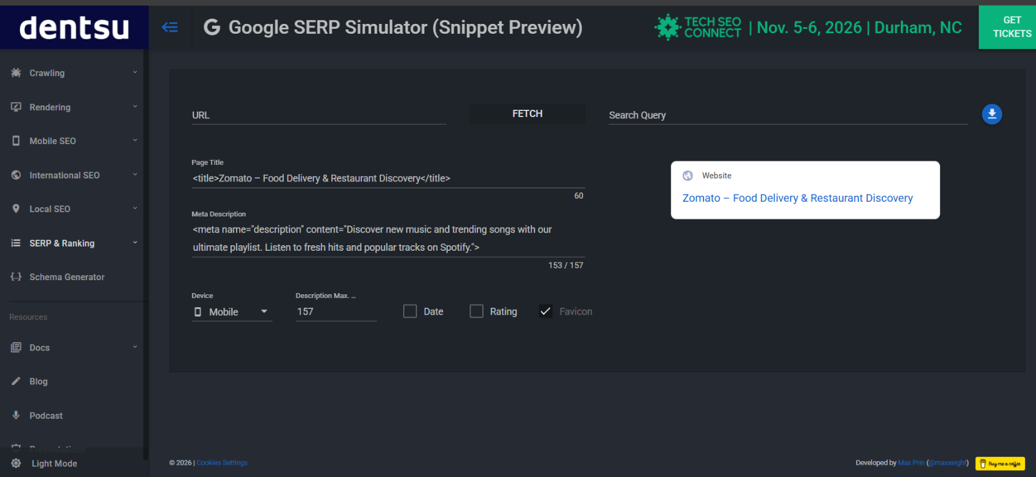Screenshot
Screenshot Explanation
The SERP simulator was used to preview the SEO title and meta description. The title is 60 characters and the meta description is 153 characters, so both are within the recommended length shown by the tool. The preview shows that the title and description are displayed properly without unnecessary truncation.

